Let’s create a Library in Angular

**ng new sonamlib --create-application=false**

this will give you work space to create your library where you can’t see any src folder.

**ng g library mylib**

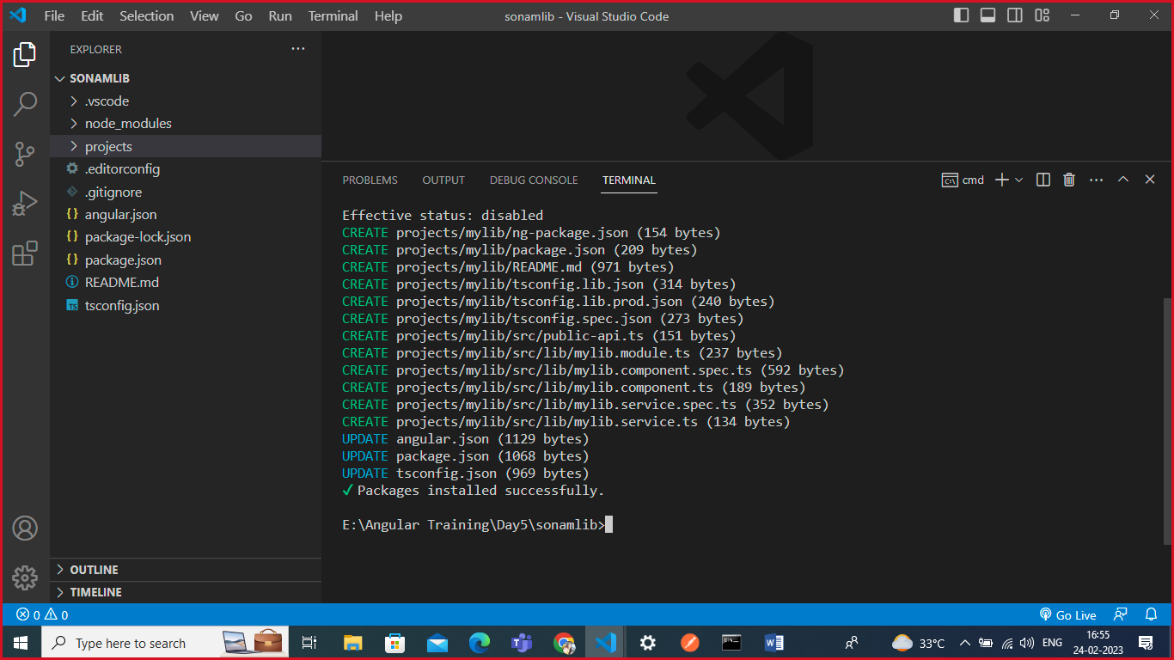

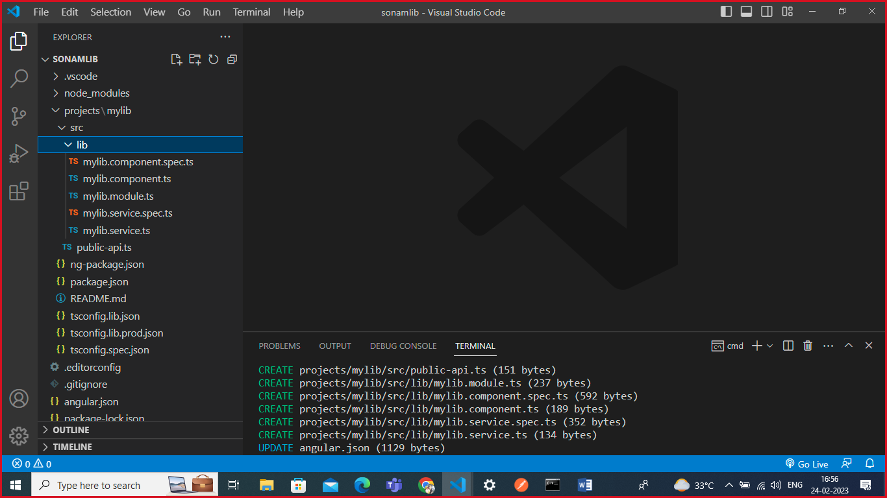

**I want to create a component inside my library.**

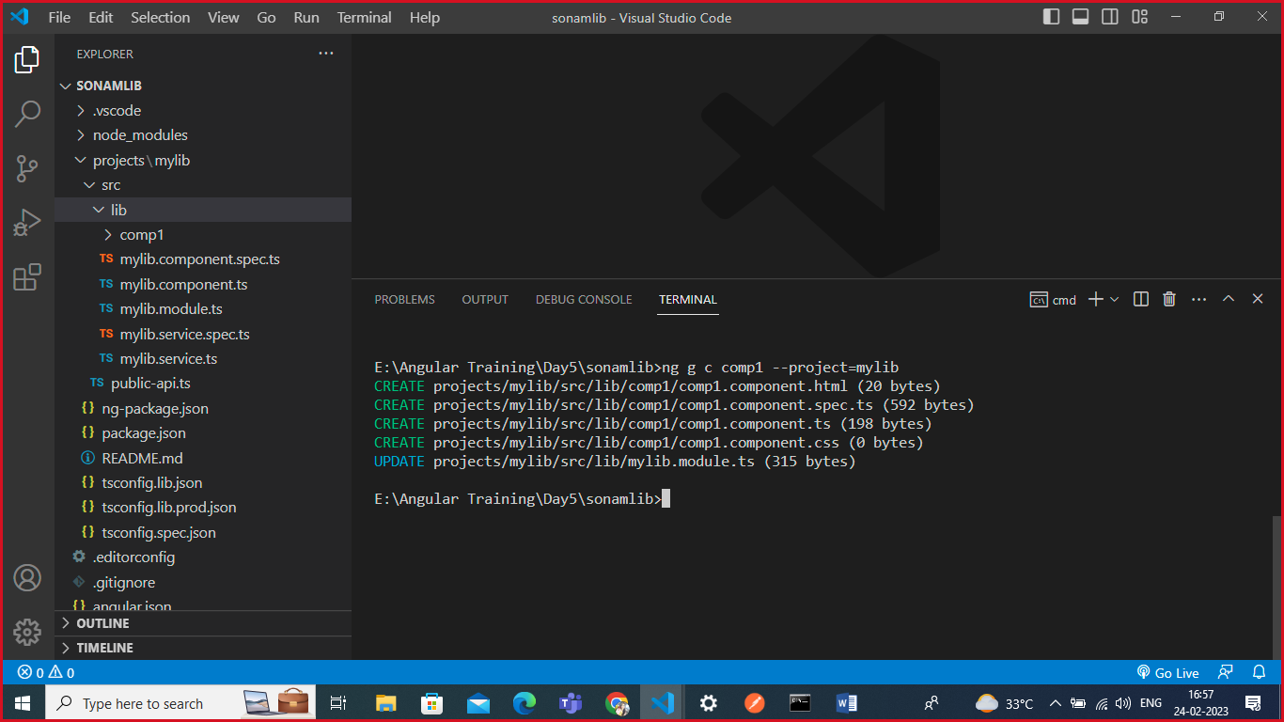

**Let’s export it from public-api.ts file**

/*

 * Public API Surface of mylib

 */

import { from } from 'rxjs';

export * from './lib/mylib.service';

export * from './lib/mylib.component';

export * from './lib/mylib.module';

export * from './lib/comp1/comp1.component';

**export from module mylib.module.ts file**

import { NgModule } from '@angular/core';

import { MylibComponent } from './mylib.component';

import { Comp1Component } from './comp1/comp1.component';

@NgModule({

  declarations: [

    MylibComponent,

    Comp1Component

  ],

  imports: [

  ],

  exports: [

    MylibComponent,

    Comp1Component

  ]

})

export class MylibModule { }

**Add script in your project’s package.json file**

{

  "name": "sonamlib",

  "version": "0.0.0",

  "scripts": {

    "ng": "ng",

    "start": "ng serve",

    "build": "ng build",

    "build-library":"ng build mylib",

    "watch": "ng build --watch --configuration development",

    "test": "ng test"

  },

**Execute the script: npm run build-library.**

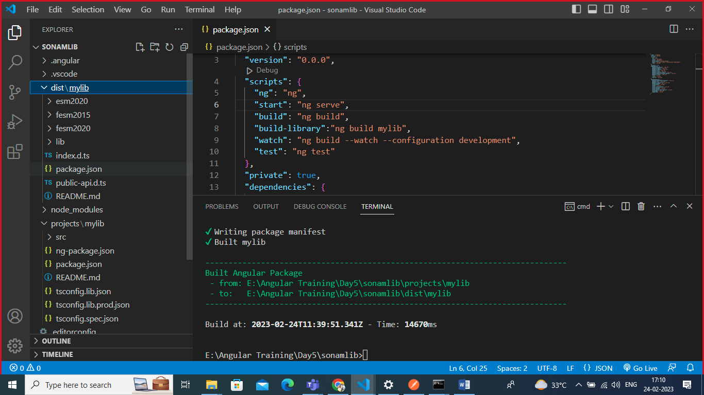

**Move to dist and library folder**

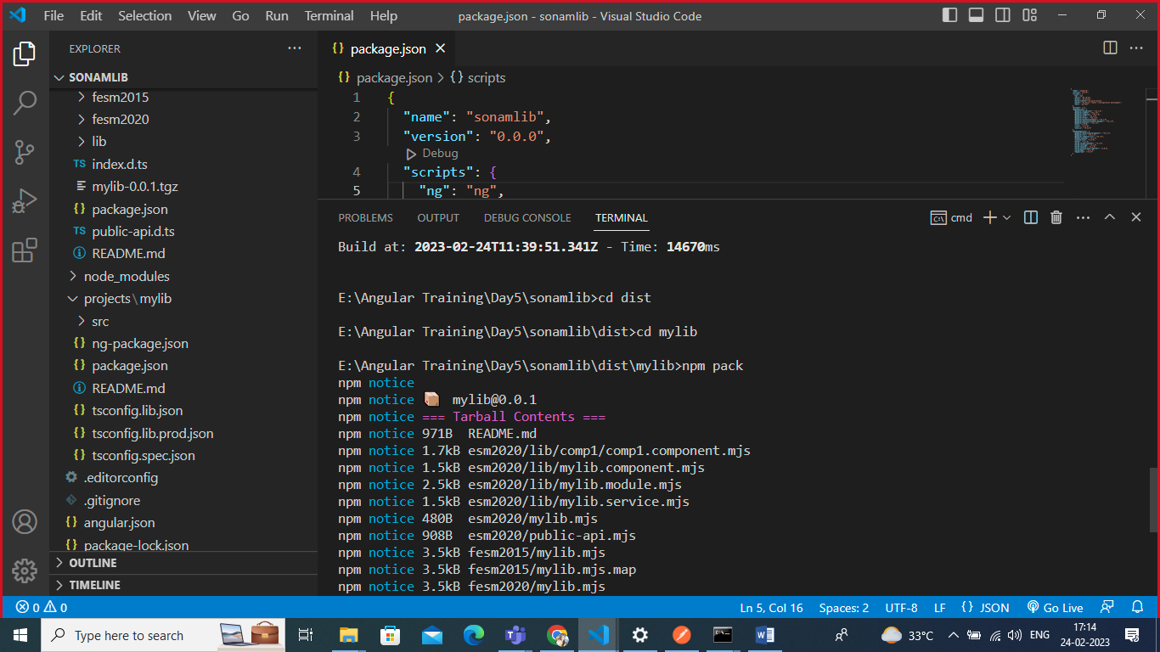

**Execute below command to install your library in your any other angular project.**

Npm install <location of that tarfile>

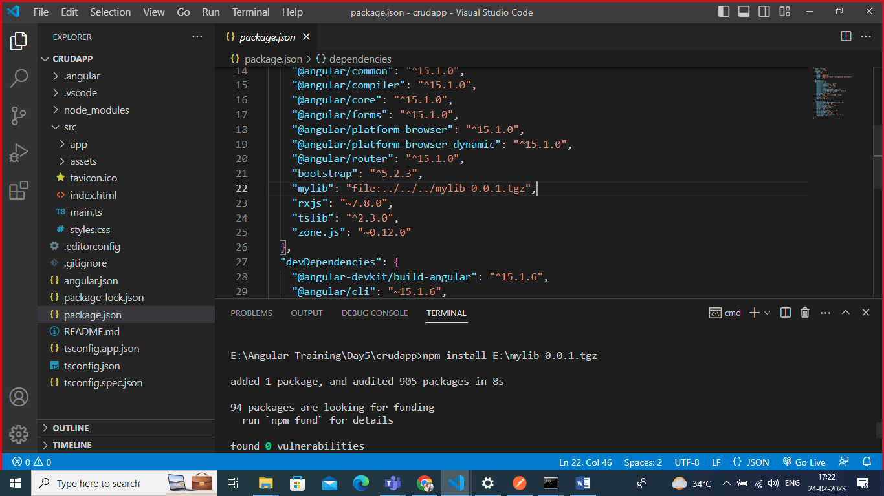

**If it’s installed successfully then you can see the package.json file updated with mylib.**

**Once this is created you can make live your library publically on npmjs.com.**

**Create account and then you can publish you’re your cmd.**

**Npm login 🡪 validate your crendentials.**

**Npm publish dist/mylib/mylib.0.0.1.tgz –access public**